Environmentalist

NAME:- MODI JAINIL MAHESHKUMAR

SUBJECT:- ENVIRONMENTAL SCIENCE

GROUP:- A

ENROLLMENT NO:- 220130107061

TOPIC:- ABOUT ENVIRONMENTALIST

1.M.YOGANATHAN:-

* Yoganathan Started Campaigning Against The Cutting Of Trees In The Nilgiris During The 1980s. He Has Visited Over 3,000 Schools Across The State To Organise Plantation Drives And Environmental Awareness Programmes. He Makes Sure That Every Sapling Planted By A School Child Is Named After The Child, And Receives Adequate Nurturing.
* 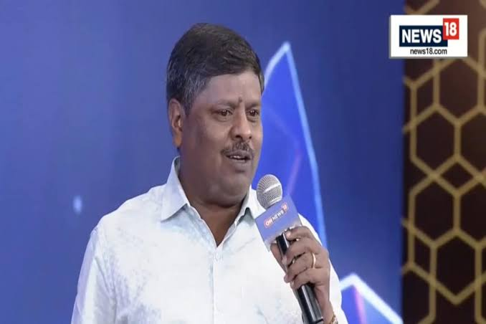Due To His Frequent Absence From Work, Yoganathan Has Been Transferred 40 Times In His 17 Years Of Service As A Bus Conductor. However, He Has Continued His Work With Dedication And Passion. He Has Been Awarded Several Awards For His Work, Including The Eco Warrior Award From The Indian Government, The Unsung Hero Award From The Wildlife Film Maker Mike Pandey And The Real Hero Award From Cnn-Ibn. He Was Born In 1969 In Coimbatore, Tamil Nadu, India.
* He Is Married And Has Two Children.
* He Is A Graduate In Tamil Literature From The Government Arts College In Coimbatore.He Is A Member Of The Tree Trust, An Organization That Works To Plant Trees And Protect The Environment.

2. SUNITA NARAIN:-

* Sunita Narain is an Indian environmentalist and political activist. She is the director general of the Centre for Science and Environment (CSE), a research and advocacy organization based in New Delhi. Narain is also the editor of the fortnightly magazine Down To Earth.
* Narain has been working on environmental issues for over 30 years. She has been a leading voice in the fight against climate change, water pollution, and air pollution. She has also been a strong advocate for sustainable development and the rights of women and children.
* 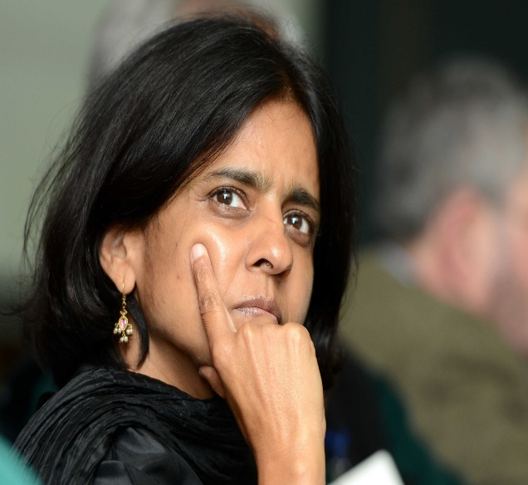Narain has received numerous awards for her work, including the Padma Shri, India's fourth-highest civilian award, and the World Water Prize. She was also named one of Time magazine's 100 Most Influential People in the World in 2016.
* She co-founded the Centre for Science and Environment in 1982.
* She has been the editor of Down To Earth magazine since 1982.
* She has written several books on environmental issues, including "The State of India's Environment" and "Excreta Matters."
* She has served on the Prime Minister's Council on Climate Change and the National Ganga River Basin Authority.
* She has received numerous awards for her work, including the Padma Shri, the World Water Prize, and the Goldman Environmental Prize.
* She was named one of Time magazine's 100 Most Influential People in the World in 2016.

3. SUMAIRA ABDULALI:-

* Sumaira Abdulali Is An Indian Environmentalist Who Has Been Fighting Against Noise Pollution And Illegal Sand Mining In India For Over 30 Years. She Is The Founder Of The NGO Awaaz Foundation And Convenor Of The Movement Against Intimidation, Threat And Revenge Against Activists (MITRA).
* Abdulali Began Her Environmental Activism In The Early 1990s, When She Noticed The Increasing Levels Of Noise Pollution In Mumbai. She Started By Filing Complaints With The Authorities, But Her Efforts Were Met With Little Success. In 1993, She Founded Awaaz Foundation To Raise Awareness About Noise Pollution And To Advocate For Stricter Regulations.
* Awaaz Foundation Has Been Successful In Bringing About Some Changes In The Law. In 2000, The Supreme Court Of India Issued A Ruling That Banned The Use Of Loudspeakers Between 10 P.M. And 6 A.M. Awaaz Foundation Has Also Been Successful In Getting The Government To Install Noise Meters In Public Places And To Crack Down On Violators.
* In Addition To Her Work On Noise Pollution, Abdulali Has Also Been A Vocal Critic Of Illegal Sand Mining. She Has Been Threatened And Attacked By Sand Mafias, But She Has Continued To Fight For The Protection Of India's Beaches And Rivers.
* Abdulali's Work Has Been Recognized By Several Awards, Including The Goldman Environmental Prize, The Right Livelihood Award, And The Padma Shri. She Is A True Inspiration To All Who Are Working To Protect The Environment.
* Founded The NGO Awaaz Foundation In 1993.
* Convenor Of The Movement Against Intimidation, Threat And Revenge Against Activists .
* Brought About Changes In The Law To Reduce Noise Pollution.
* Got The Government To Install Noise Meters In Public Places And To Crack Down On Violators.

4. MIKE PANDEY:-

* 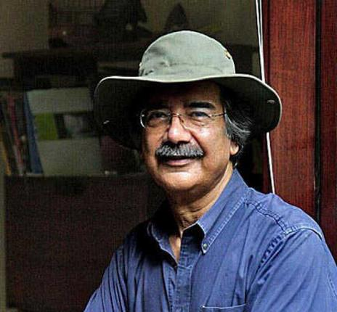Mike Pandey Is An Indian Filmmaker Who Specializes In Films About Wildlife And The Environment. He Is The Founder Of The Production House Earth Matters, Which Has Produced Over 600 Films And Won Over 300 Awards. Pandey's Films Have Been Screened At Major Film Festivals Around The World And Have Helped To Raise Awareness About Environmental Issues Such As Climate Change, Deforestation, And Animal Poaching.
* Pandey Was Born In Kenya In 1962. He Grew Up In A Family That Was Passionate About Wildlife Conservation, And He Developed A Love For Nature At A Young Age. He Moved To India In 1979 To Study Filmmaking At The Film And Television Institute Of India. After Graduating, He Started His Own Production Company, Earth Matters, In 1984.
* Pandey Is A Passionate Advocate For Environmental Protection. He Believes That Films Can Be A Powerful Tool For Raising Awareness About Environmental Issues And Inspiring People To Take Action. He Has Traveled All Over The World To Screen His Films And To Speak About The Importance Of Environmental Conservation.
* Pandey Has Received Numerous Awards For His Work, Including The Padma Shri, India's Fourth-Highest Civilian Award, And The Wildscreen Panda Award. He Is A Member Of The World Wildlife Fund's International Council For The Protection Of Nature And The World Conservation Union's Species Survival Commission.

5. ARUN KRISHNAMURTHY:-

* 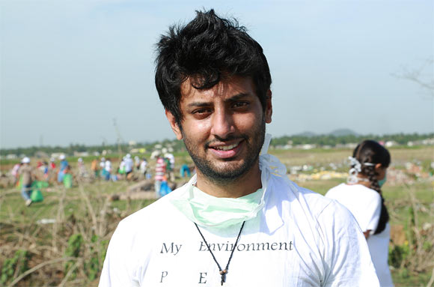Arun Krishnamurthy Is An Indian Environmental Activist Who Has Initiated The Campaign Of Cleaning Various Lakes Across India. He Is Known For Founding The Environmentalist Foundation Of India (EFI) 2011 Based In Chennai Which Has Its Branches In 15 States And Other Cities Such As Hyderabad, Delhi And Coimbatore. Arun With The Organisation Has Been Successful In Cleaning At Least 169 Lakes In The Country And Having Worked In Google Before Quitting The Job To Dedicate Voluntarily. He Was Chosen As Among The Five People For Prestigious Rolex Awards For Enterprise Award In 2012 For Scientific Lake Restoration In Chennai.
* Arun Krishnamurthy Was Born In Chennai, India In 1986. He Studied Microbiology At Madras Christian College And Then Went On To Earn A Master's Degree In Mass Communication From The Indian Institute Of Mass Communication. After Working As An Account Associate At Google For Three Years, Krishnamurthy Quit His Job To Focus On Environmental Activism.
* In 2011, Krishnamurthy Founded The Environmentalist Foundation Of India (EFI). EFI Is A Non-Profit Organization That Works To Protect And Restore The Environment. EFI's Work Includes Cleaning Lakes, Planting Trees, And Educating The Public About Environmental Issues.
* Founded The Environmentalist Foundation Of India (EFI) In 2011.
* Led EFI's Efforts To Clean Over 169 Lakes In India.
* Received The Rolex Awards For Enterprise, The Goldman Environmental Prize, And The Right Livelihood Award.

6. Jadav Payeng

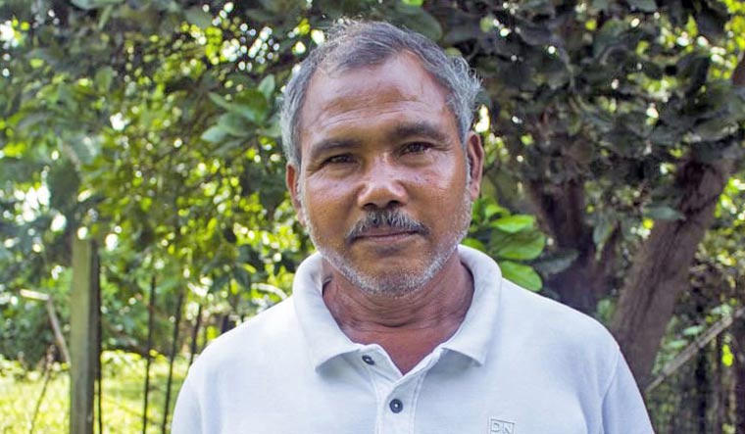

* He was born in 1963 in Assam, India. He is an environmentalist activist and forestry worker from Majuli. Popularly known as the "Forest Man of India". For several decades, he has planted and tended trees on a sandbar of the river Brahmaputra, which has turned into a forest reserve. The name of the forest is Molai Forest, which was kept after him and is located near Kokilamukh in Jorhat, Assam, India. The forest encompasses an area of about 1,360 acres. He was honoured with the Padma Shri, the fourth-highest civilian award in India, in 2015.

7. Monkombu Sambasivan Swaminathan

* 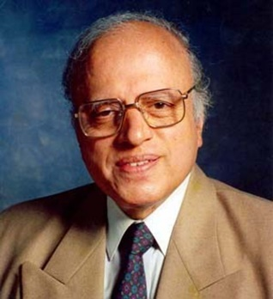He Was Born On August 7, 1925, In Kumbakonam, Tamil Nadu, India. He Is An Agricultural Scientist, Plant Geneticist, Indian Agronomist, Administrator, And Humanitarian. He Is Renowned For His Leading Role In India's "Green Revolution." It Is A Programme Under Which High-Yield Varieties Of Wheat And Rice Seedlings Are Planted In The Fields Of Poor Farmers. "He Also Helped Introduce Mexican Semidwarf Wheat Plants To Indian Fields And Also Helped In Bringing Greater Acceptance Of Modern Farming Methods. He Was Also The Director-General Of The Indian Council Of Agricultural Research From 1972 To 1979. From 1979 To 1980, He Was The Principal Secretary Of The Indian Ministry Of Agriculture And Irrigation. He Was Director-General Of The International Rice Research Institute (1982–88) And Was Also President Of The International Union For Conservation Of Nature And Natural Resources (1984–90)."

8. S. P. Godrej

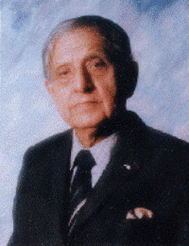He Was Born On June 3, 1912, In Bombay Presidency, British India. Popularly, He Was Known As Soli. He Was An Indian Businessman, Entrepreneur, Environmentalist, Philanthropist, And Chairman Of The Godrej Group Of Industries. He Was Connected With Several Organisations Committed To The Preservation Of Nature, Wildlife, And The Environment As President Emeritus Of The World Wide Fund For Nature-India. He Was Also The President Of The Bombay Natural History Society, The President Of The National Society Of The Friends Of The Trees, And The Patron Of The Family Planning Association Of India. He Was Also A Governing Board Member Of The Population Foundation Of India, Among Others. He Received Several Awards, Including The Indira Gandhi Pariyavaran Puraskar In 1991.

10. Salim Ali

* 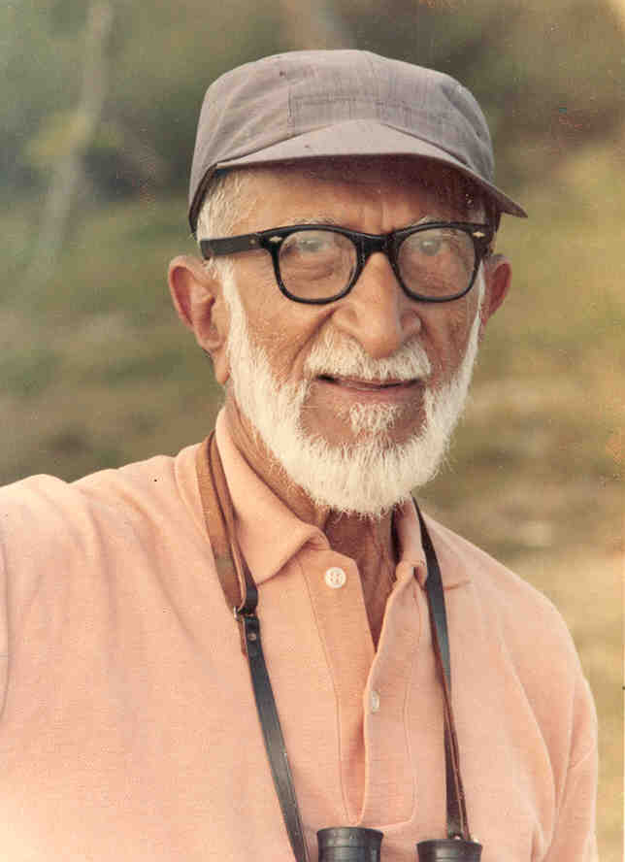He Was Born On November 12, 1896, In The Bombay Presidency, British India. He Was Also Known As The "Birdman Of India." He Was An Indian Ornithologist And Naturalist. He Was Also The First Indian Who Conducted Systematic Bird Surveys Across India And Wrote Various Bird Books That Popularised Ornithology In India. He Played An Instrumental Role In Creating The Bharatpur Bird Sanctuary (Keoladeo National Park). He Also Prevented The Destruction Of What Is Now The Silent Valley National Park. In 1976, He Was Awarded The Padma Vibhushan, And In 1958, The Padma Bhushan. He Was A Leading Conservation Scientist And Also Influenced Environmental Policies In Our Country. He Died On June 20, 1987, In Bombay, Maharashtra, India
* Gadgil Has Received Numerous Awards For His Work, Including The Padma Shri (1983), The Padma Bhushan (2006), The Volvo Environment Prize (2003), And The Tyler Prize For Environmental Achievement (2015). He Is A Fellow Of The Indian Academy Of Sciences, The Indian National Science Academy, And The Third World Academy Of Sciences.

10.rajendra singh

* 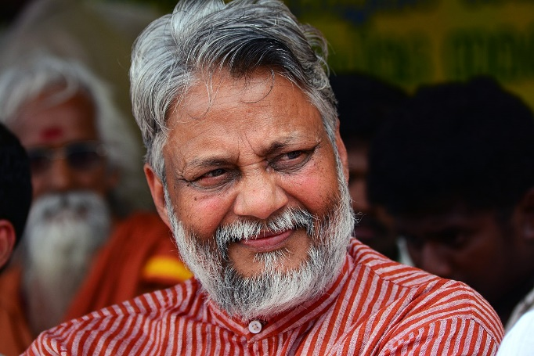Singh Was Born In 1959 In A Small Village In Baghpat District, Uttar Pradesh. He Studied Ayurveda And Hindi Literature At The University Of Allahabad. After Graduating, He Moved To Alwar District In Rajasthan, Where He Began Working With The Tarun Bharat Sangh (TBS), A Non-Governmental Organization (NGO) That Works On Water Conservation And Rural Development.
* Under Singh's Leadership, TBS Has Helped To Build Over 8,600 Johads, Small Dams That Collect Rainwater, In Over 1,000 Villages In Rajasthan. These Johads Have Helped To Restore Water Supplies To Many Villages That Were Previously Facing Water Scarcity. Singh Has Also Helped To Revive Five Rivers In Rajasthan: The Arvari, Ruparel, Sarsa, Bhagani, And Jahajwali.
* For His Work In Water Conservation, Singh Has Received Numerous Awards, Including The Ramon Magsaysay Award In 2001 And The Stockholm Water Prize In 2015. He Is Also A Member Of The National Ganga River Basin Authority (NGRBA), A Government Body That Is Responsible For The Management Of The Ganges River.